Date: June 3, 2021
To: Weber County Board of County Commissioners

From: Ronna Tidwell
Community Development Department

Agenda Date: June 8, 2021

Subject: Request to Declare Parcel Number 13-151-0006 as Surplus Property

Attachments: A – Aerial View of Parcel
B – Recorder’s Plat
C – Market Value

_____________________________________________________________________________________

Summary:
Parcel Number 13-151-0006 was struck off to Weber County in the 1992 tax sale. The County has recently been approached about selling this property. Weber County has no intended use for this property, therefore, it will be declared surplus and offered for sale to another interested buyer. In order to convey real property, the County Commission must first take action to declare this parcel as surplus property.

Property Description:
13-151-0006
PART OF LOT 6, EL MONTE VISTA SUBDIVISION , UNIT 1, LYINGWITHIN THE BOUNDARIES OF THE NORTHEAST QUARTER OF THESOUTHWEST QUARTER OF SECTION 22, TOWNSHIP 6 NORTH, RANGE1 WEST, OGDEN CITY, WEBER COUNTY, UTAH.

Recommendation:
Declare Parcel 13-151-0006 as surplus property.

Fiscal Impact:
Because the property is valued at less than $10,000 by the County Assessor’s Office, there is no requirement for additional documentation to determine fair market value. Parcel 13-151-0006 is valued at $128.

Attachment A
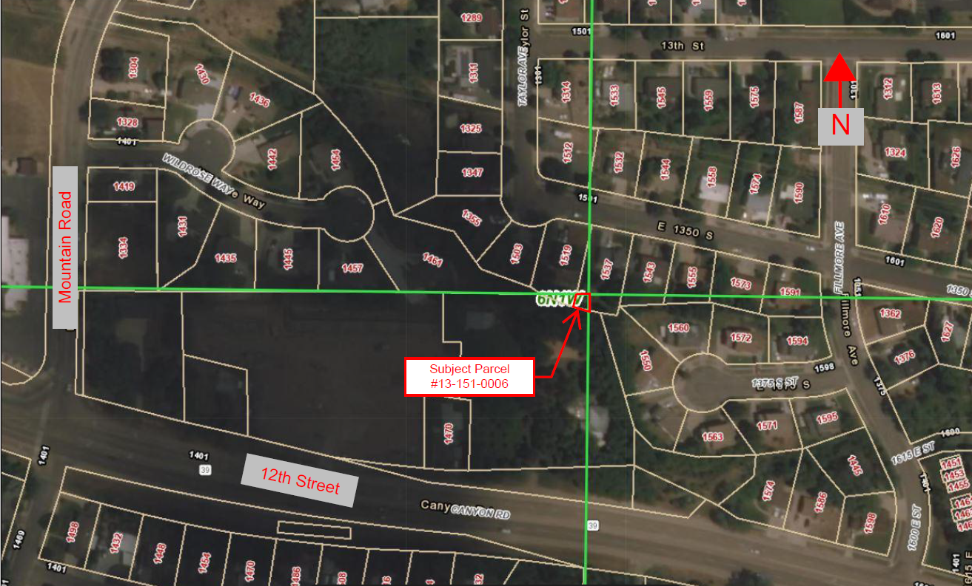

Attachment B
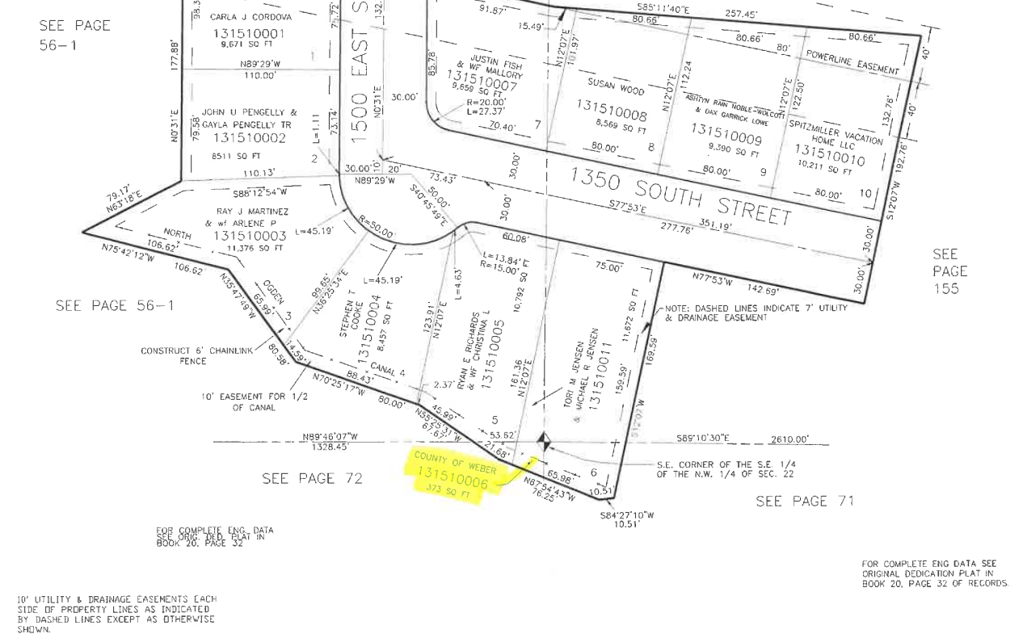

Attachment C

